**Credential Expiration**

1.Credential getting expired on reaching the expiry date.

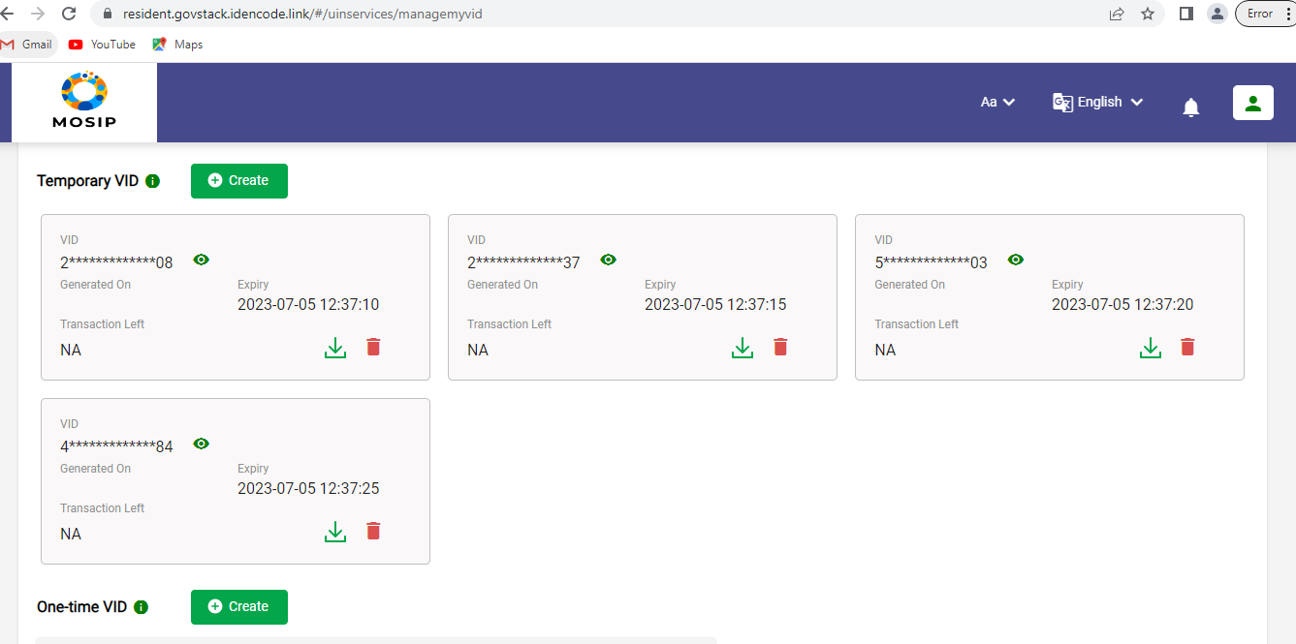

2.Prior notification for credential expiration, credential going to expire in next 24 hours.



3.Credentials moving to vid_expiry list table after batch job run.

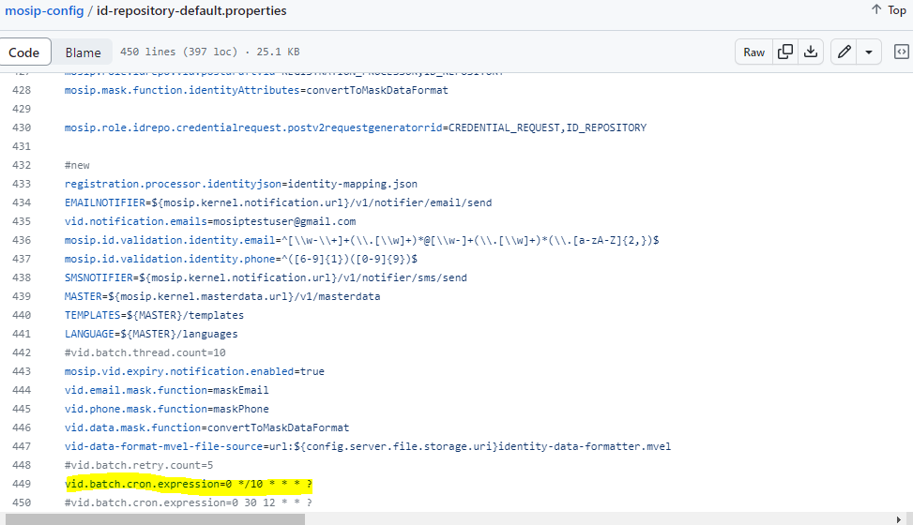

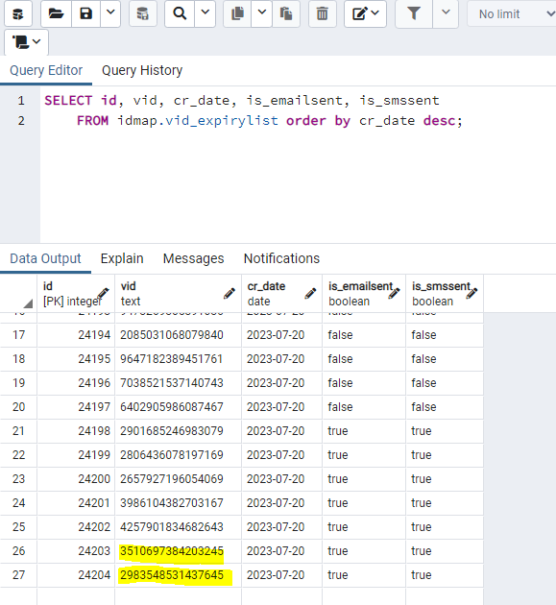

4.Audit table displaying count of expired credential in the log_desc column.

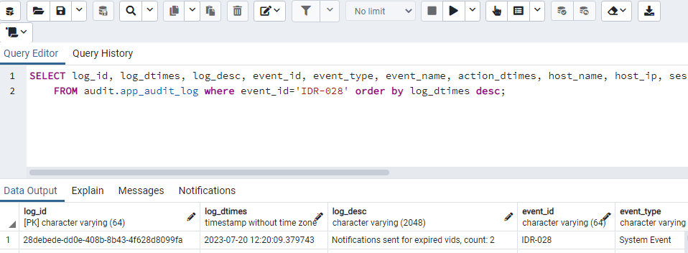

**Integration flows with the Expired Credentials**

1. 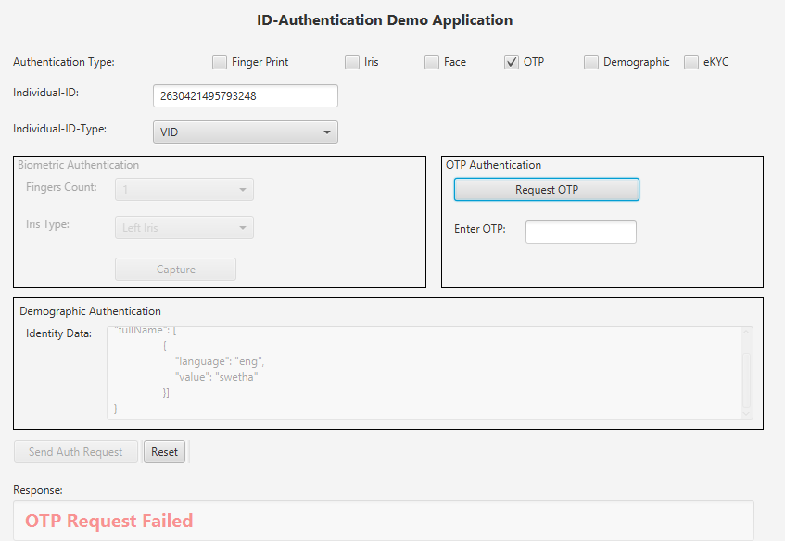Send OTP with the expired credential

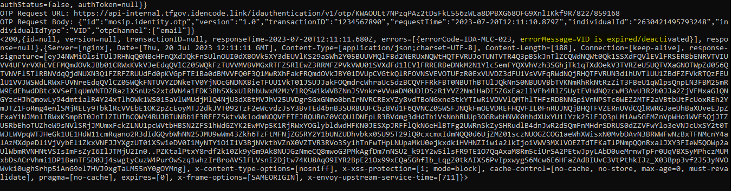

1. Demo Authentication with Expired credential

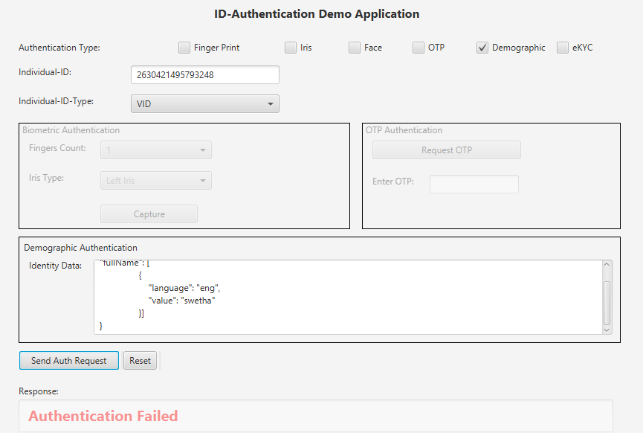

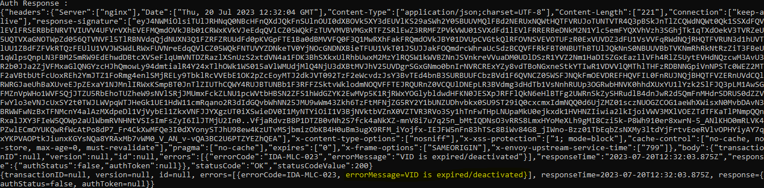

1. 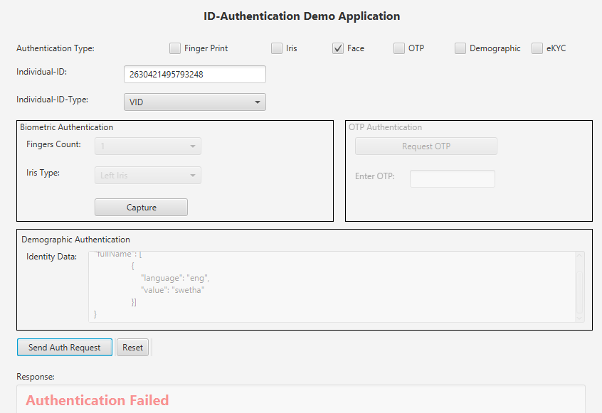Bio authentication for face with the expired credential

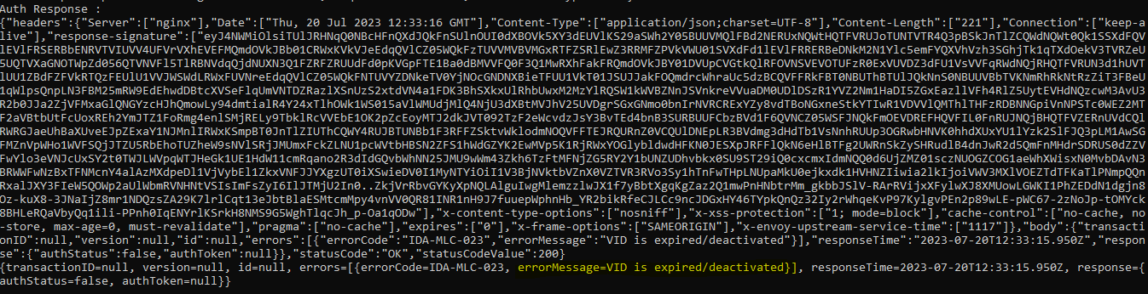

1. Bio authentication for finger with the expired credential

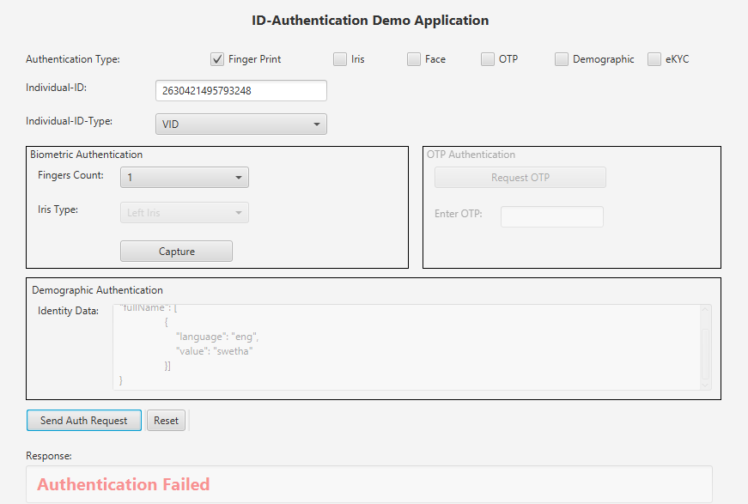

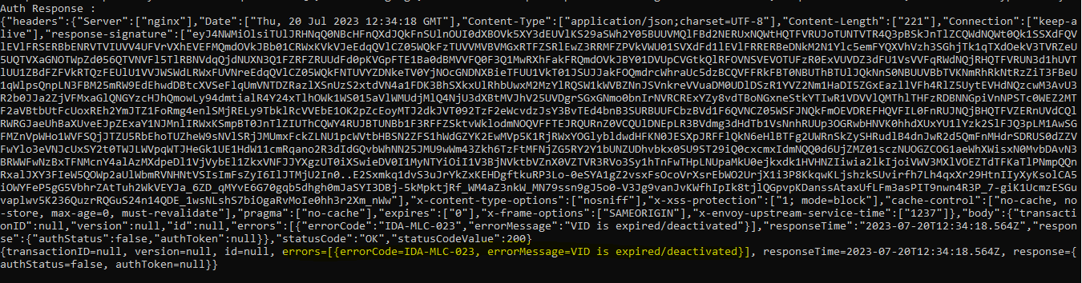

1. 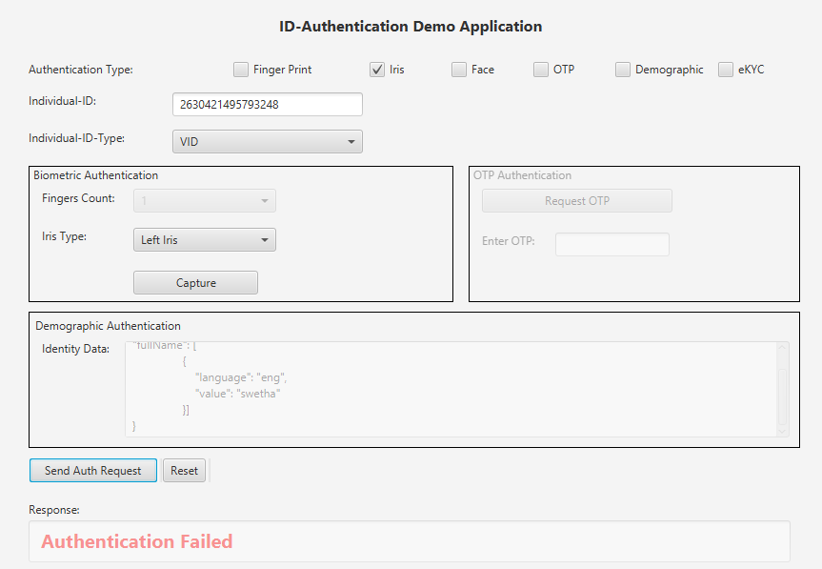Bio authentication for iris with the expired credential

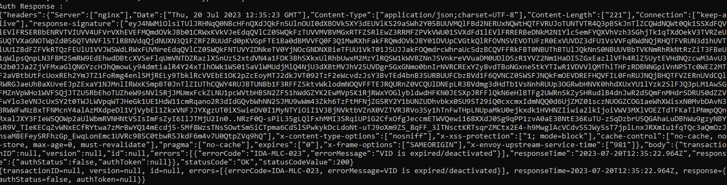

1. Ekyc authentication with the expired credential

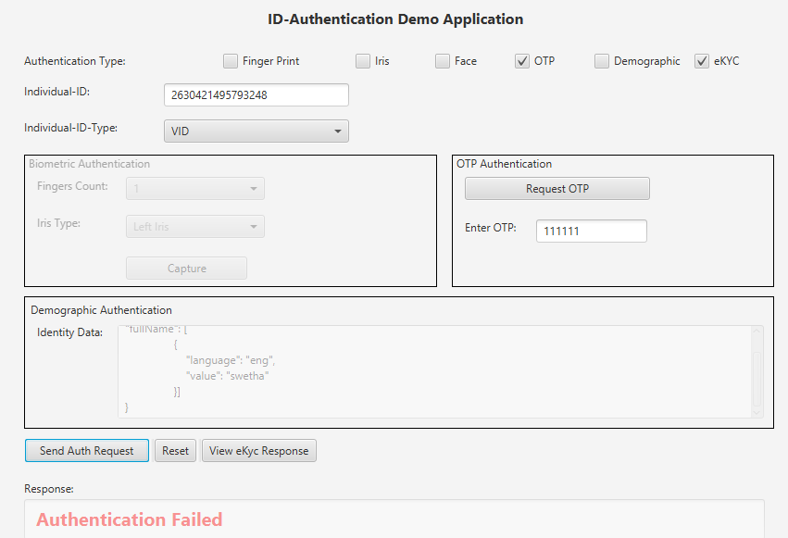

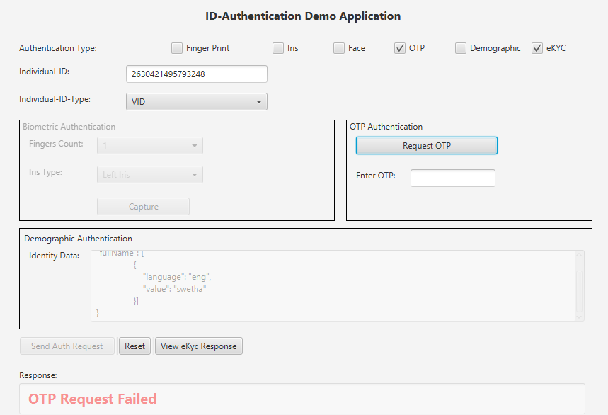

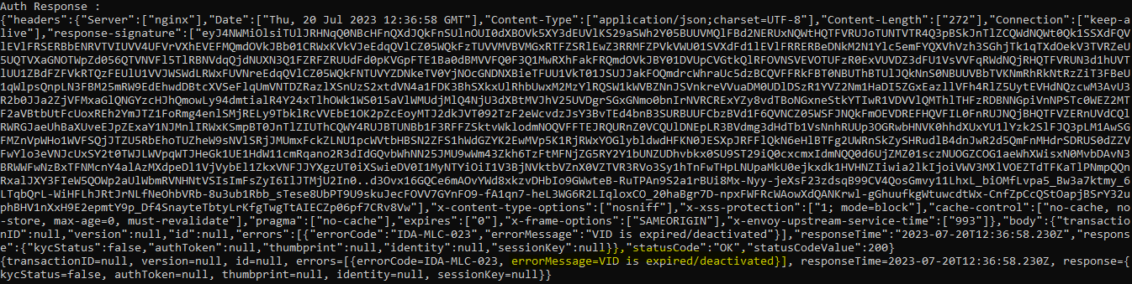

1. 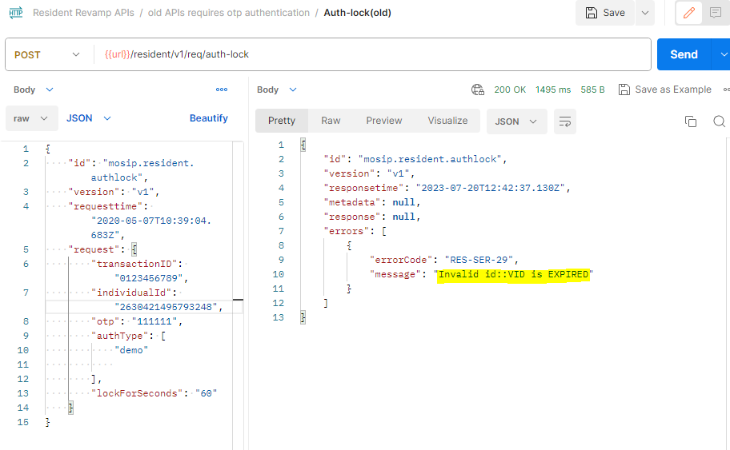Auth lock with expired Credential.
2. Auth unlock with expired Credential.

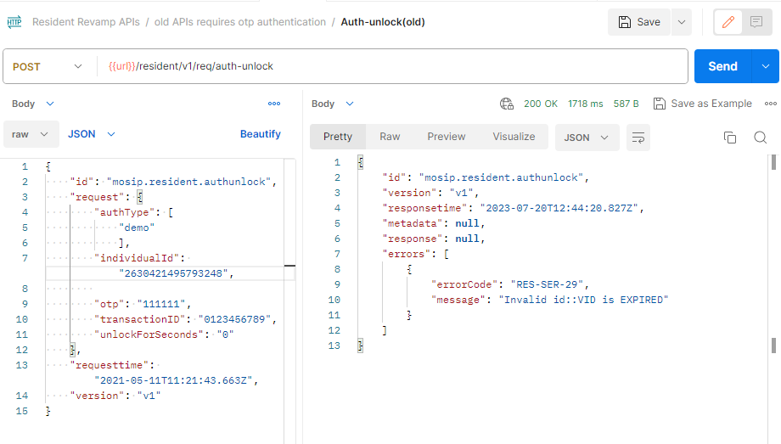

1. 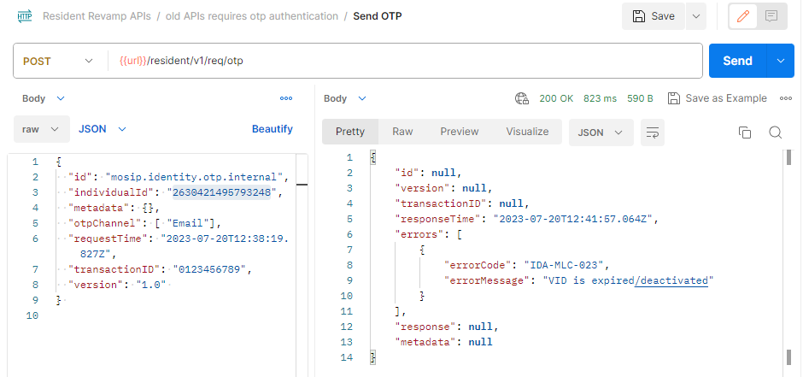Download card for Expired Credential.
2. 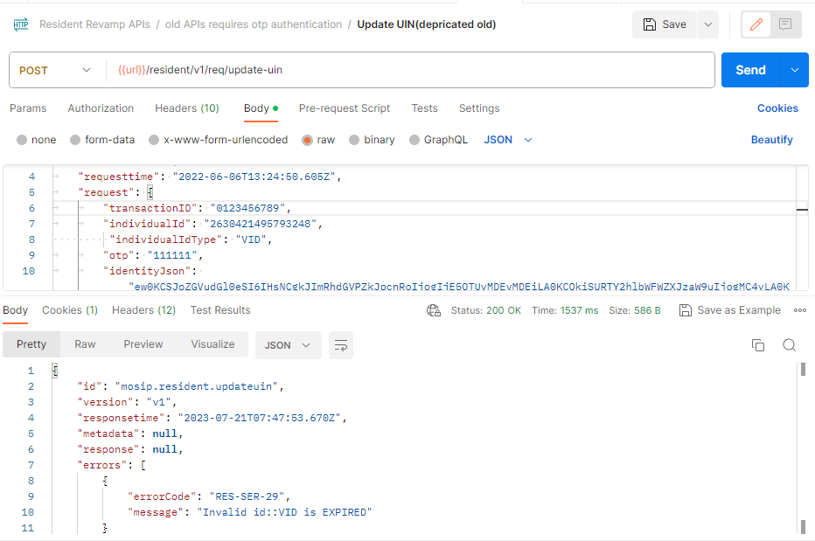Credential update for the expired Credential
3. Login to resident service portal with OTP for expired credential

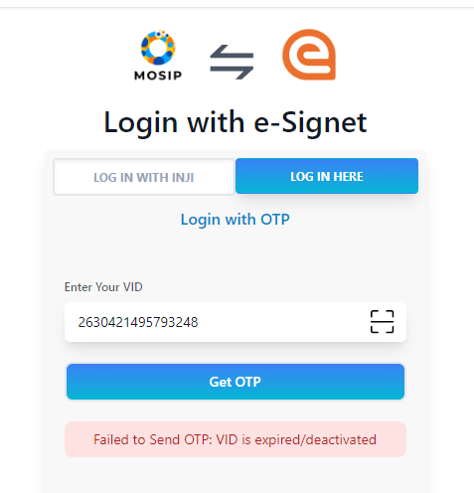

1.  Login to resident service portal with biometric for expired credential
2. Fetch Expired credential details

